**CS 628 Full-Stack Development II**

**HOS02A Web Application with Express**

July 16, 2020

12/29/2020 Updated by Min

School of Technology & Computing (STC)

City University of Seattle (CityU)

**Before You Start**

* The directory path shown in screenshots may be different from yours.
* This HOS does not explain all steps in detail**.** If you are not sure what to do:
  1. Consult the resources listed below.
  2. If you cannot solve the problem after a few tries, ask a TA for help.

**Resources**

* Express Hello World, <https://expressjs.com/en/starter/hello-world.html>
* What is a Package? <https://www.w3schools.com/nodejs/nodejs_npm.asp>
* Template Literals, <https://developer.mozilla.org/en-US/docs/Web/JavaScript/Reference/Template_literals>

**Learning Outcomes**

Students will be able to:

* Understand how the Express works as the de facto server-side web application framework for Node.js.
* Apply two formatting practice to your programming:
  + Use semicolons to delimit statements.
  + Use template literals for multi-line strings and string interpolation.

**Activities**

* Preparing for a MEAN project environment
* **Developing a simple web application with Express**
* Pushing your work to GitHub

**Preparing for a MEAN project environment**

1. Create the “module02a” folder under your repo:  
   >>>mkdir module02a  
   you will see like that:
2. 
3. Open the “module02a” folder in the VSCode.  
   Close the “Welcome” window.  
   Open the terminal (Ctrl+`).

**Developing a simple web application with Express**

1. Type the following command in the terminal to initialize a Node project:  
   >>>npm init --yes  
   Watch what file was generated.  
   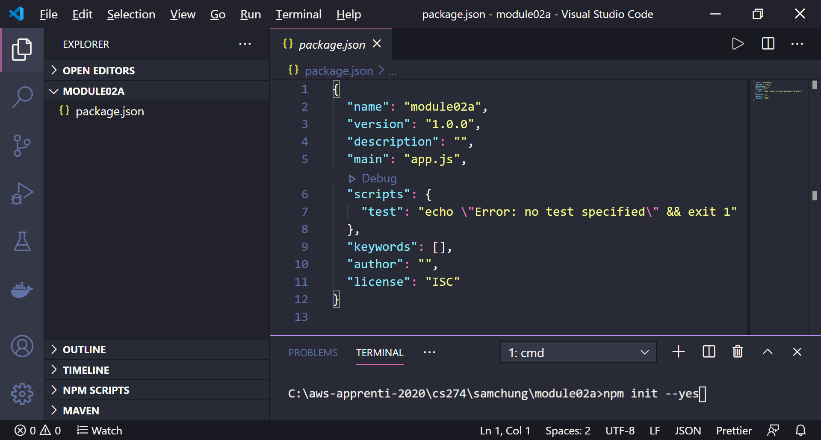
2. Install a package called ‘express.’  
     
   **npm install express**  
     
   Watch what file and directory were generated.  
   Watch what change happened in the “package.json” configuration file.  
   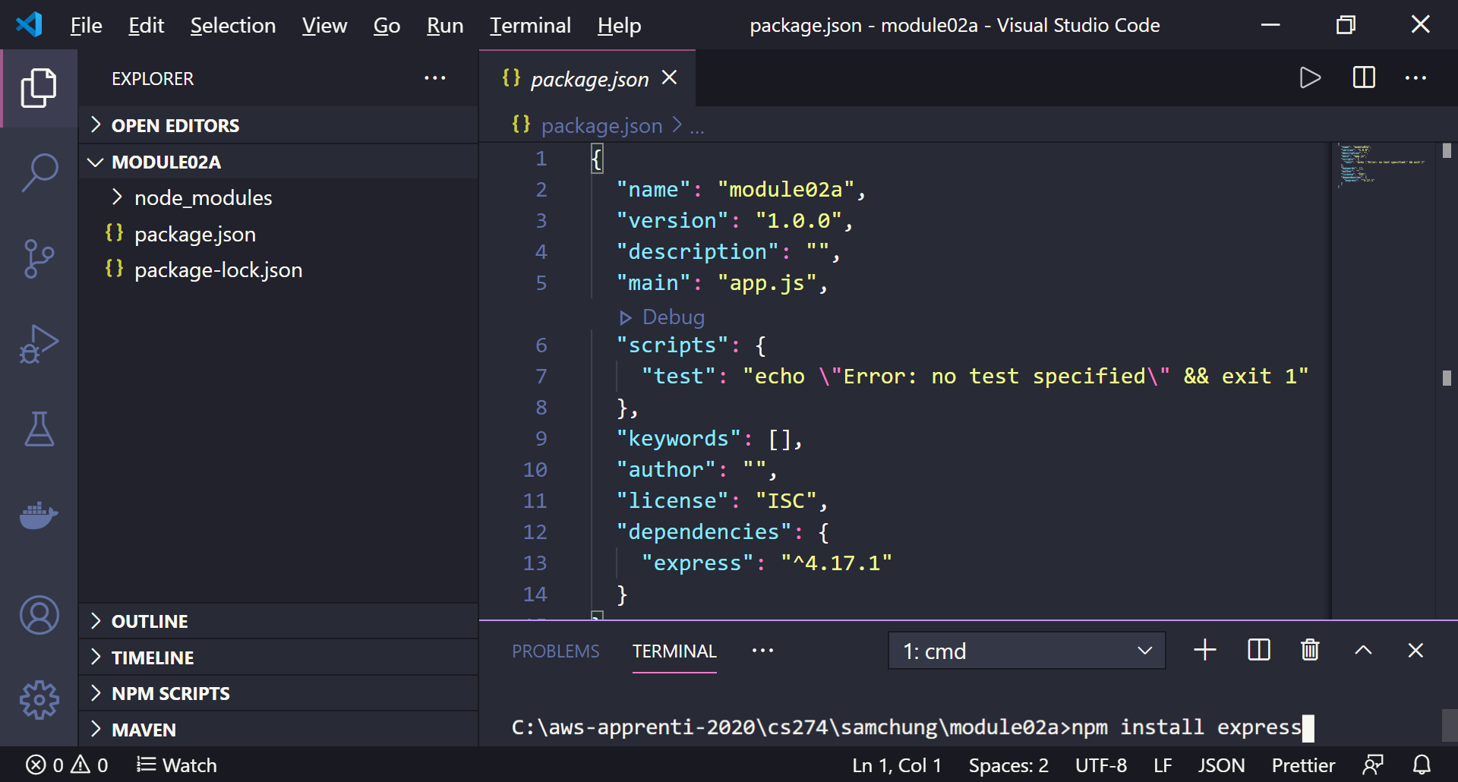
3. Create an app.js file.  
   Type the following code.  
   Then, execute the code.  
   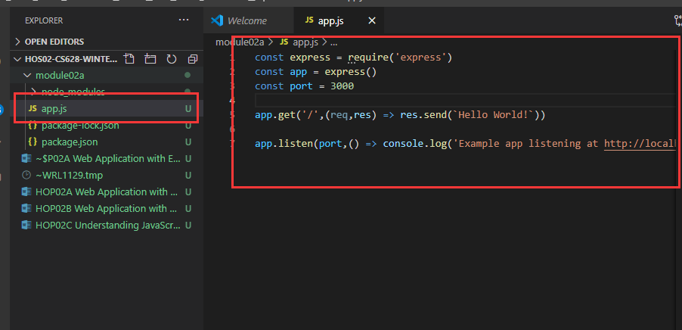  
     
   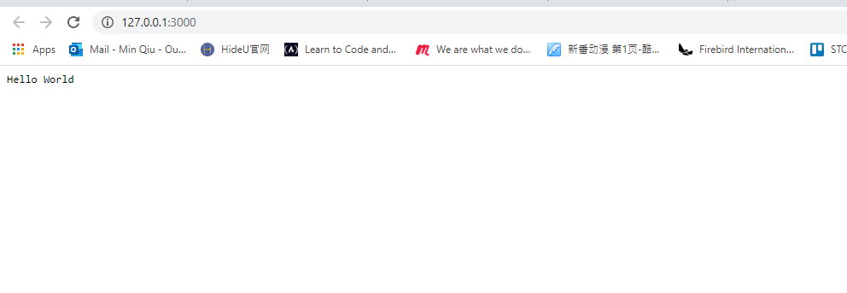
4. Compare this source code with the source code of the native Node web application in HOS01F below. How does the Express affect the web application development?

Seems to get rid of boilerplate code.  
  
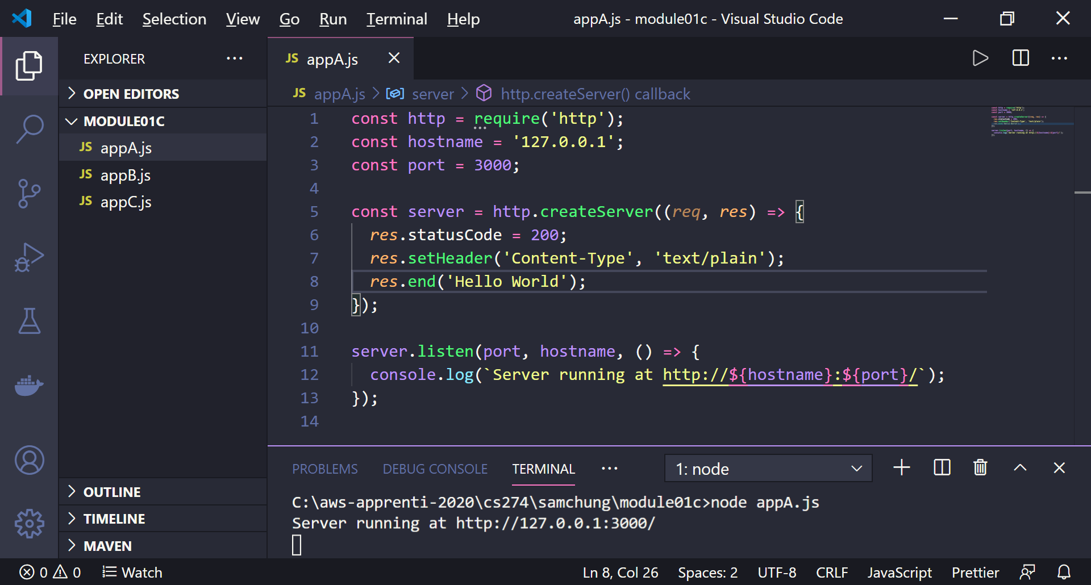

Improve the source code and its display.

* 1. All statements end with the semicolon delimiter.
  2. We will display the <h1> output using a template literal.  
     Template literals are enclosed by the backtick (` `) (grave accent) character instead of double or single quotes.

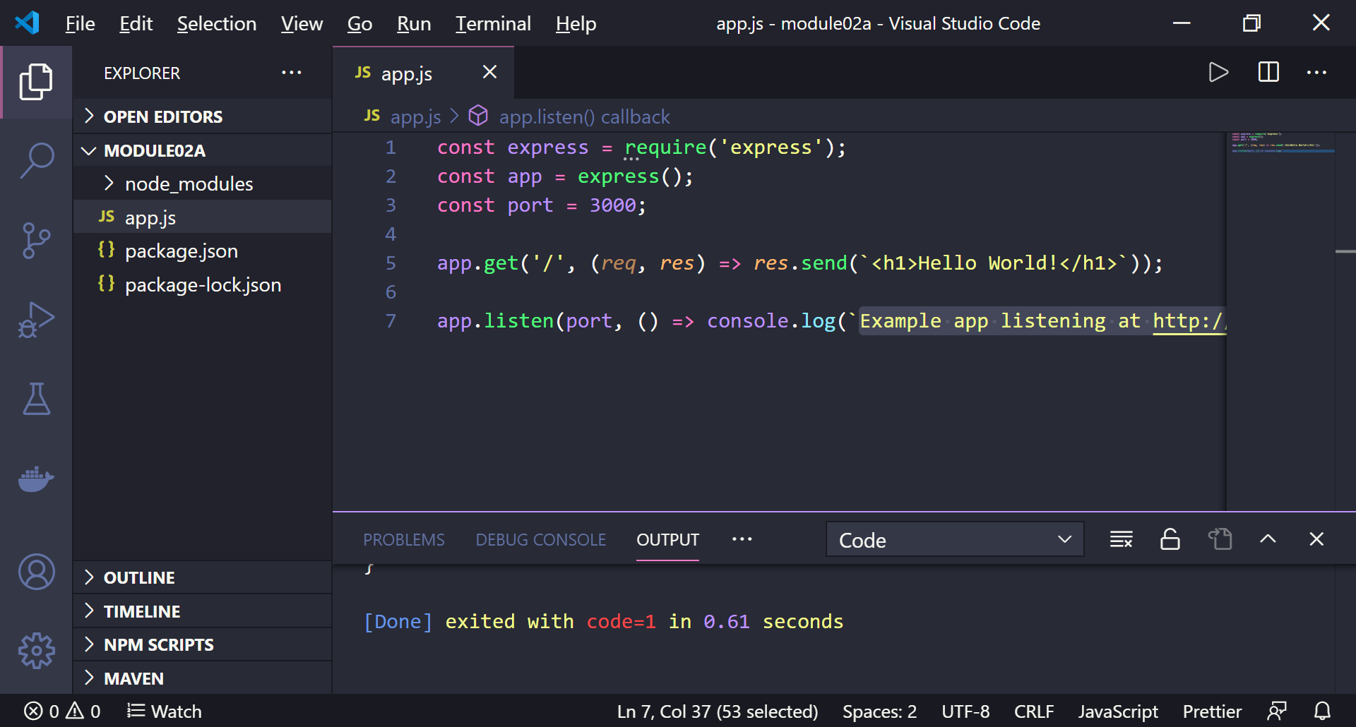

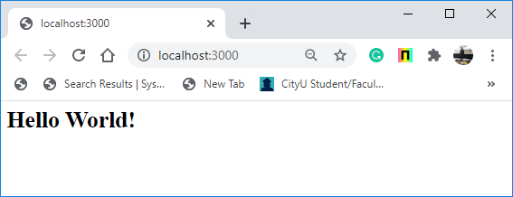

**Pushing your work to GitHub**

Run the following commands to push your work to the GitHub repository:

Open the terminal from the VSCode by hitting the control + ~ key and type the following command:

>>> git add .

>>> git commit -m “Submission for Module 2 --yourname”

>>> git push origin master

If you cannot remember your branch name, run the command “git status” to check.